UART(universal asynchronous receiver-transmitter)

Configuration in STMCUBEMX:

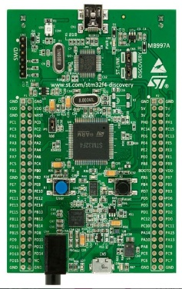--> 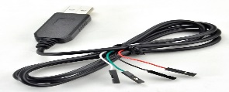-->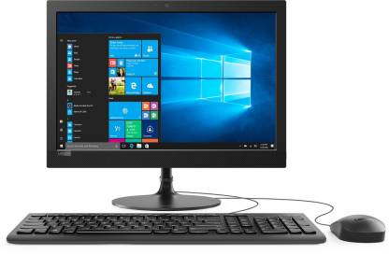

PreConfig: We will be using Internal Clock so no need to change anything in clock tree always use default config.

1.Select SYS->serial wire.

2.Select UART4-> asynchronous.

3. Select SYS->serial wire.

4. Click on configuration->click on UART4->click on parameter settings and make the following changes:

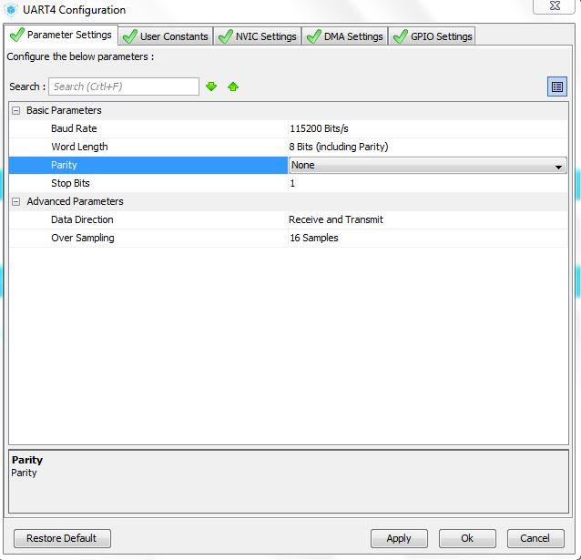

6. .Click on DMC setting🡪add🡪select UART4_RX 🡪Apply and OK.

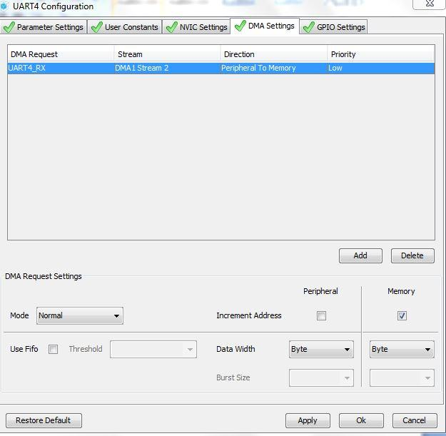

7. . Then click on Apply and OK and generate code.

8. Open main.c make the following changes in code .

9.Add the header **#include “string.h” and**

Define the char rx[30] in //USER CODE BEGIN 0//

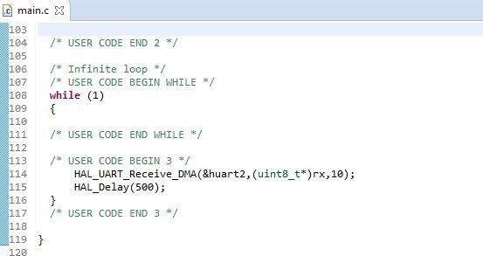

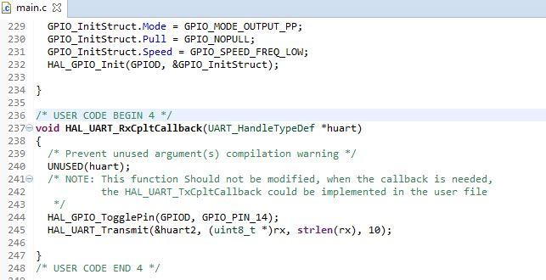

10.Build the project and Run.

11. For Linux Machine

1. sudo apt-get install minicom
2. Getting the USB to Serial Hardware Port

$dmesg

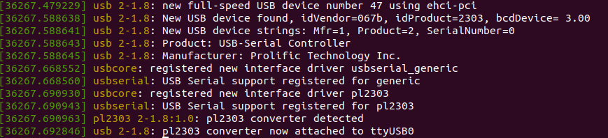

Last Line of dmesg command will be mentioning about the port no, in the above case its **ttyUSB0**

1. Start minicom with below command

$sudo minicom -D /dev/ttyUSB0

1. Baud Rate Configuration in Minicom

Using minicom if you do Ctrl+A then Z, and then press P for port parameters, you can press A to cycle through the standard baud rates that minicom has.